**Factory Method Pattern Implementation**

OUTPUT SCREENSHOT

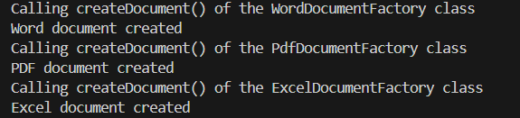

CODE ANALYSIS

* **Product Interfaces –** interfaces which will be implemented to create the products
  + WordDocument – interface for creating a Word document
  + PdfDocument – interface for creating a PDF document
  + ExcelDocument – interface for creating an Excel document
* **Concrete Products –** classes which implement the Product interfaces
  + concreteWord – concrete class for creating a Word document
  + concretePdf – concrete class for creating a PDF document
  + concreteExcel – concrete class for creating an Excel document
* **Factory Interface –** interface for creating the products
  + DocumentFactory – interface with the factory method
* **Concrete Factories –** classes which implement the Factory interface
  + WordDocumentFactory – concrete class for factory of Word documents
  + PdfDocumentFactory – concrete class for factory of PDF documents
  + ExcelDocumentFactory – concrete class for factory of Excel documents
* **Test class –** class for checking the logic
  + Demo – contains the main method which commences the code execution

INFERENCE

Thus, the DocumentFactory interface is being used to implement concrete factories which create the required products or documents, all of which are being created by the concrete classes implementing the WordDocument, PdfDocument and ExcelDocument interfaces.